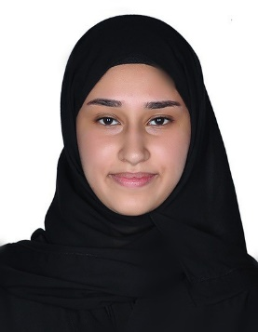MARIAM SAYED ABDULKHALEQ MAJEED AHMED ALAWI

Personal Information:

* CPR: 010505237
* Gender: Female
* Nationality: Bahraini
* Age: 18
* Date of Age: 18-5-2001
* Address: Road:3808 – Block:438 – Home:330 Alqalaa
* Telephone Number: 33157635
* Email: [Mryama3674@gail.com](mailto:Mryama3674@gail.com)

Qualifications:

* High school

Languaga:

* Arabic: Excellent Speaking , Reading and writing
* English: Good Speaking , Reading